VR AI NOTES
9-Week Project Timeline

Week 1: Foundation & API Integration
02-13-2026
- Unity project setup
- XR simulator
- Basic scene with heart models
- Set up Groq API (LLM, STT, TTS)
- Test full pipeline in desktop mode
- Initial VR build & headset test
- Milestone: AI conversation working, tested in VR

Week 2: VR Interaction & Context System
02-20-2026
- Build and test on Quest headset regularly
- Implement gaze detection (what user is looking at)
- Create VisualizationData scriptable object system
- Add metadata to heart models
- Update LLM system prompt to be generic (not heart-specific)
- Test context-aware responses in VR
- Milestone: Bot knows what you're looking at and responds contextually

Week 4: Bot Model & Basic Animation
03-06-2026
- Source/import humanoid bot model
- Position in scene, test scale in VR
- Add basic animations (idle, talking gesture)
- Test bot visibility and presence in VR
- Adjust positioning and scale based on VR comfort
- Milestone: Bot model present and animated in VR

Week 5: Bot Integration & Audio
03-13-2026
- Connect bot animations to audio playback
- Add simple lip sync or jaw movement
- Implement bot gaze (looks at user or at visualization)
- Test audio spatialization in VR
- Refine bot behavior based on VR testing
- Milestone: Bot speaks with synchronized animation

Week 5 & 6: Particle System
04-03-2026
- Design particle swarm
- Implement responsive particle behavior
- Particles react to AI state (idle, listening, speaking)
- Position and tune for VR visibility
- Milestone: Both embodiments functional in VR

Week 7: Scene Polish & Lighting
04-10-2026
- Finalize scene layout based on VR feedback
- Implement proper lighting
- Add environment details (pedestals, subtle UI)
- Performance optimization for Quest (maintain fps)
- Test with different users for comfort
- Milestone: Polished, well-lit, comfortable VR scene

Week 8: Multiple Visualization Types
04-17-2026
- Add a simple bar graph visualization (cell type counts)
- Add metadata to graph
- Test bot answering questions about graphs vs 3D models
- Refine context detection (handle multiple objects in view)
- Continue VR testing and comfort optimization
- Milestone: Bot works with different visualization types

Week 9: Final Polish & Documentation
04-24-2026
- Final testing with multiple visualization types
- Record demo video (both embodiments)
- Update documentation
- Milestone: Complete, demo-ready, documented

10/02/2026

- Scene
- Basic scene with human heart. Could ask the bot to tell how two heart models differ or maybe which cell type occurs the most?
- Use HRA 2.4 models for it. https://github.com/cns-iu/hra-organ-gallery-in-vr-development/tree/main/hra-organ-gallery/Assets/Models/Organs/2.4/HiRes
- No constraints on scene wrt the skybox, env, etc. There’s flexibility.

- Bot
Humanoid
- Humanoid model - stay away from the uncanny valley.
- Look at Fab, Unity assets, Sketcfab.
- Could import animations from Mixamo, the model needs to be properly rigged for this.
- If not mixamo, use Blender to create animations.

Particles
- Use a particle system. Something like Navi from Legend of Zelda
https://youtube.com/shorts/ShXbpyPgbOg?si=ExUsNCbHkE6o5rOU
- An entity that follows you around (not in an annoying way)
- Maybe a pulsing swarm instead of something that fades over time so that the user does not feel like they have limited time to interact with the entity.
- Andi mentioned HRA red fading to white (color over lifetime)

12/02/2026

Pricing:

Complete AI Pipeline:
- STT (Speech-to-Text): User talks in VR → converts to text
- LLM (Language Model): Text question → generates text answer
- TTS (Text-to-Speech): Text answer → audio for bot to speak

Option A: OpenAI Ecosystem (simplest)
- STT: OpenAI Whisper API - $0.006 per minute
- LLM: GPT-4o mini - very cheap (~$0.15 per 1M input tokens)
- TTS: OpenAI TTS - $15 per 1M characters
- Pros: Single API provider, great documentation, reliable
- Estimated cost for 7-8 weeks: $10-30 total

Option B: Mix & Match (cheapest)
- STT: OpenAI Whisper - $0.006/min
- LLM: GroqAI (LLaMa 3) - FREE tier is generous, super fast
- TTS: ElevenLabs free tier or $5/month
- Pros: Cheapest, GroqAI is extremely fast
- Estimated cost: $0-15 total
- Cons: Managing multiple APIs
ElevenLabs has a built-in Unity SDK, and is explicitly marketed for VR.

13/02/2026

- Will have to look into lighting. The models need to be well lit from all angles.
- Create a timeline for the project. We have 9 weeks. April 24th.
- The bot can have basic animations rn (idle and talk)
- This could be a scene in HRA. The idea is for the user to be able to have a conversation about the visualizations and models, and have their queries answered in real time.

17/02/2026

- Groq API key: 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
- 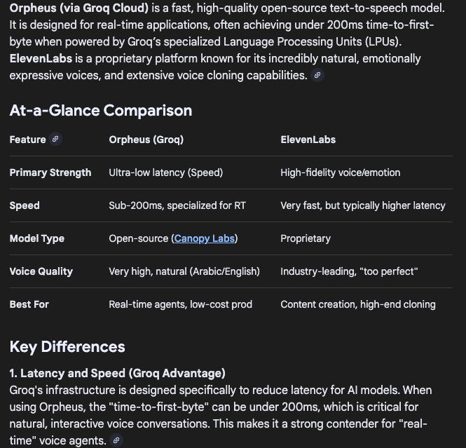
- Groq has all 3 services (STT, LLM, TTS)
- STT: Whisper Large v3 Turbo
- LLM: Llama 4 Scout
- TTS: Orpheus English
Will try using Orpheus (has fewer voices but very low latency)
- Context for bot:
- Scriptable Objects that can be attached to each visualization. Can use JSON/text files that provide metadata from external files (useful for non-programmers but SO better imo)
- The bot can look at a game object and detect through raycast and then pull up context about that specific game object. Makes it more dynamic that way.

19/02/2026
- Used up 3.5k tokens for orpheus tts. The limit is 3.6k. That makes it expensive.
- Elevenlabs Flash on the other hand will give me about 20 minutes of audio where one minute of audio costs approximately 1000 characters.
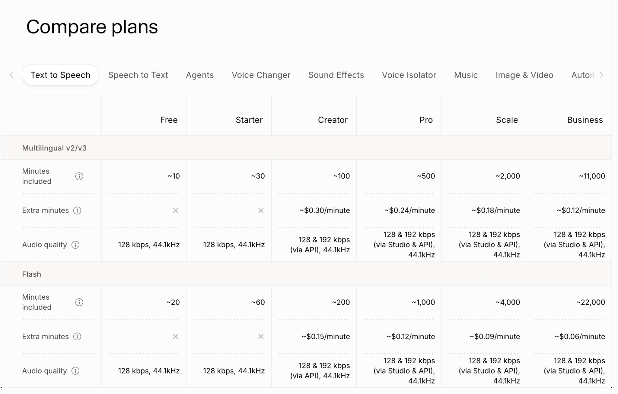
- The starter tier is $5 month and increases usage limit quite a bit.

20/02/2026
- ElevenLabs API key:
Sk_c4fe0a87504049908eb3272b634071d92551b29621d3c450
- Super low latency: ~75ms
- 40k character limit (Orpheus has 3.6k). Could use the free tier for now and see if we need the $5/month in the future.

24/02/2026

- Try multiple visualization types in the scene and see how that compares to the 3d models and how the AI Manager interacts with those as well.
- Updated Unity version. Using Unity 6.3 LTS (6000.9f1) now.
- Updates some of the deprecated assets and components that I used in the 2022 version.
- Using XR Interaction Simulator instead of XR Device Simulator now since that’s Legacy and lacks many of the newer features.

26/02/206

- Downloaded free 3d models from SketchFab (.blend or .fbx). Not sure if they’re rigged.

Updates for today (March 06, 2026):

Still working on the particle swarm. Yesterday I spent some time going through YouTube tutorials on Blender animations and general tools to get more comfortable with the working. The animations are taking a bit longer than expected, but I'm making progress and have a clearer idea of what I need to do.
Will keep pushing on it today.

10/03/2026

- Type 2 — Orb/Sphere with implied structure. The white smoky sphere and the blue cellular/energy orb both have a loosely spherical form that feels contained but turbulent inside. The blue one especially is interesting because it actually looks like a cell — which is a fantastic happy accident given your anatomical context. It has that organic membrane quality with an energetic core.
- This direction has a clear center of gravity — the entity "lives" in a defined space, which makes it easier for users to know where to look and talk to. It feels more like a being while still being abstract.

- My honest take combining both types:
- I'd actually suggest a hybrid — a loose orb as the resting/idle state that occasionally trails off into ribbons or wisps when active or speaking. The sphere gives it a home base, the flowing tendrils give it expressiveness.
- The blue cellular orb is particularly compelling for your project because it visually rhymes with the anatomical content users are exploring.

So the concept would be something like:
Idle state — a gently pulsing orb, particles slowly orbiting/churning within the sphere boundary, calm blue-purple glow
Listening state — orb tightens slightly, maybe a subtle inward pull, indicating attention
Speaking/active state — tendrils start trailing off from the orb, ribbons of smoke/energy flowing outward, more chaotic and expressive, brighter
Thinking/processing — could do a fast swirl or a brief contraction before expanding again
This gives users clear readable states which is important for UX in VR — they need to know when to talk and when to wait.

When adding to GITHUB add to ARCHIVES folder

i

